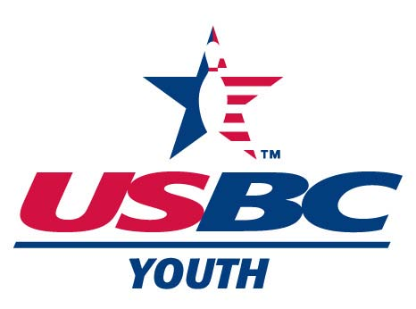

Illinois State USBC Association
OUTSTANDING YOUTH VOLUNTEER
NOMINATION FORM

Nominee’s Name:
Address:
City, State and Zip Code:
Phone Number: ( ) Email (if known)
Local USBC Association:
Bowling Center(s) affiliation:
Registered Volunteer? (Circle one) Yes No If Yes, date expires:

Please write a statement describing what your nominee has accomplished to foster, organize/support and promote certified youth bowling programs at the local, state and/or national level. Please include documentation of items supporting your nomination, such as nominee’s prior recognitions through awards, articles, letters, etc. Please be specific. (Use additional sheet, if needed.)

Nominator’s name:
Address:
City, State and Zip Code:
Phone Number: ( ) Email:
Your affiliation/relationship with the nominee:
Please sign and date: Date
Please attach any letters of recommendation (i.e. Association Board members, employers, clergy, etc.)
Mail to:
Oustanding Youth Volunteer
Patti Mauerman
25765 Eastpoint Rd., Tremont, IL 61568
pattimauerman@gmail.com

THE DEADLINE FOR FILING AN APPLICATION FOR CONSIDERATION IS OCTOBER 1, 2025.

