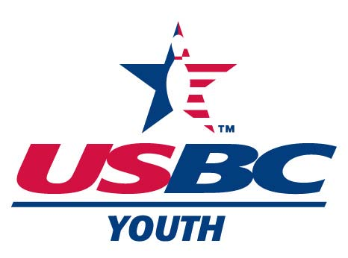

Illinois State USBC Association
OUTSTANDING YOUTH COACH
NOMINATION FORM
Requirements to apply: Must be a resident of Illinois but does not have to coach in Illinois

Nominee’s Name:
Address:
City, State and Zip Code:
Phone Number: ( ) Email (if known)
Local USBC Association:
Bowling Center(s) nominee coaches at:
Number of years coaching youth bowlers:
Registered Volunteer? (Circle one) Yes No If Yes, date expires:
Level I, Bronze, Silver or Gold level instructor certificate # & year earned or any certificates earned. (not a requirement):
Occupation and Title:
Please write a statement on the nominee’s history, service and accomplishments (use additional sheet, if needed).

Nominator’s name:
Address:
City, State and Zip Code:
Phone Number: ( ) Email:
Your affiliation/relationship with the nominee:
Please sign and date: Date
Please attach any letters of recommendation (i.e. Association Board members, employers, clergy, family member etc.) Maximum of 3.
Mail to:
Outstanding Youth Coach of the Year
Patti Mauerman
25765 Eastpoint Rd., Tremont, IL 61568
pattimauerman@gmail.com

THE DEADLINE FOR FILING AN APPLICATION FOR CONSIDERATION IS OCTOBER 1, 2025.

